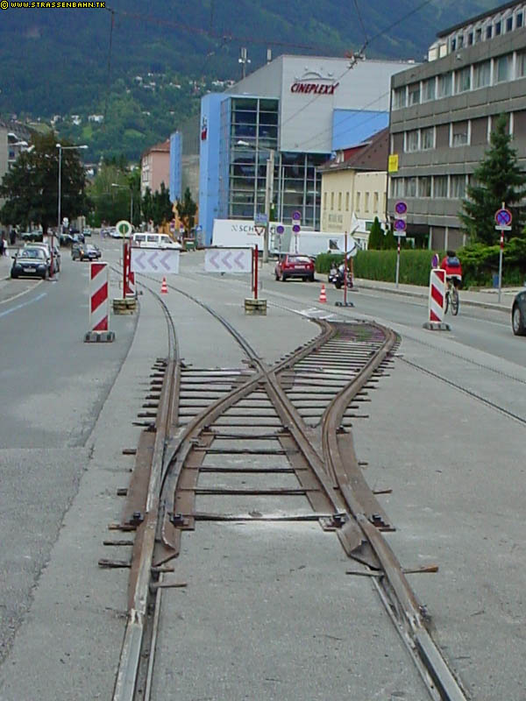  Kletterweichen (‘Climbing turnout’) in place in Innsbruck, Austria, showing ramp section up from existing rail, shallow rail section mounted on road surface and flat plates acting as ties to hold the rails to gauge | The utilities do not have to be moved, a simple crossover can be designed in at the planning stages or later a Kletterweichen, or temporary tracks can be used to carry tramways round temporary obstructions in the track, without having to interrupt the tram service.  They can be extremely short – many first generation streetcar lines in the United Kingdom had them in service, Europe and the US have Hose Bridges to allow trams & streetcar service to continue when the Fire Brigade attended the frequent fires in 19/early 20 century including war-time.  They can be quite complex, such as the temporary turnouts used to allow single track working, or they can be relatively long, running parallel to a section of track being replaced.  The temporary track consists of a steel bar the shape of the head of a conventional tramway rail, but with a flat base instead of a vertical web. The base allows the rails to stand on the road surface or on temporary packing, with spikes or bolts driven into the road surface to hold the rail in place.

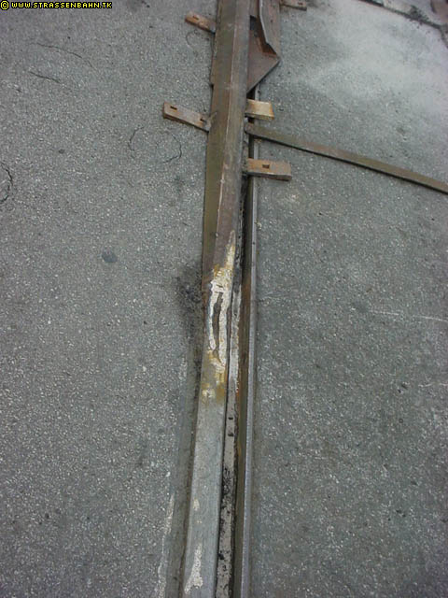

Close up of beginning of temporary track, showing ramp rail with temporary weld onto rail head, the temporary weld will be removed and rail head reprofiled when temporary track is removed

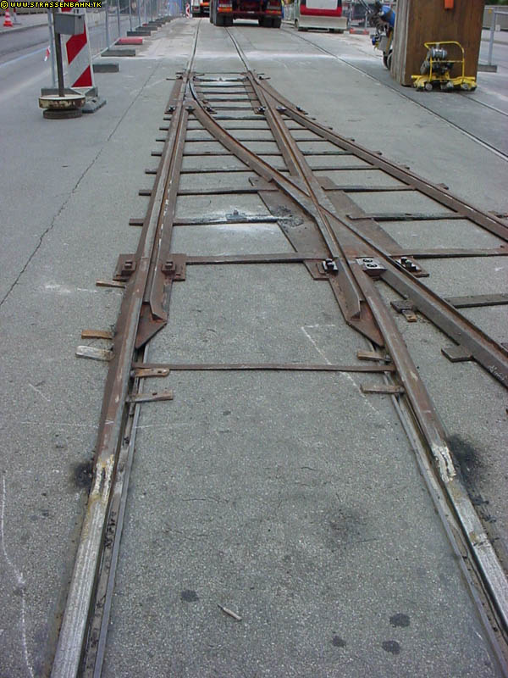

View of turnout from common crossing end

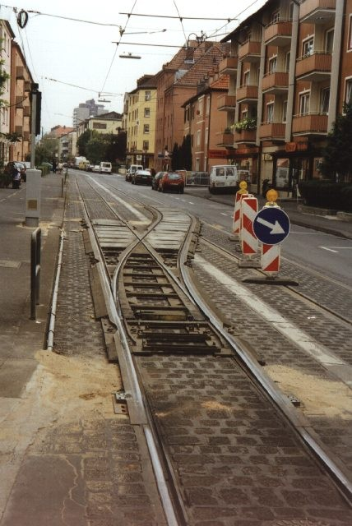  View of temporary crossover laid in to permit single line working, note temporary fitting of crossover wire in overhead to allow trams to continue to draw current as they pass through the turnout | 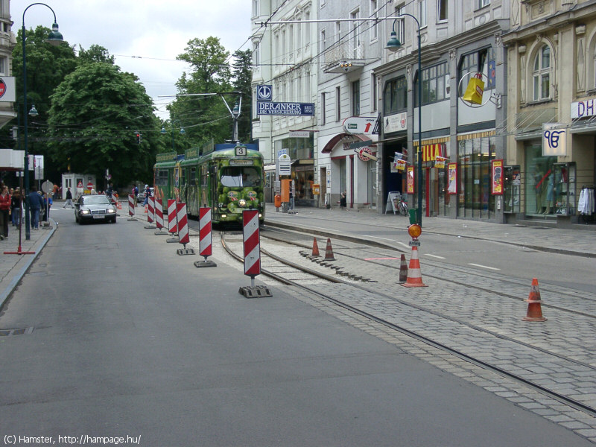  Temporary track with kletterweichen at tram stop in Innsbruck

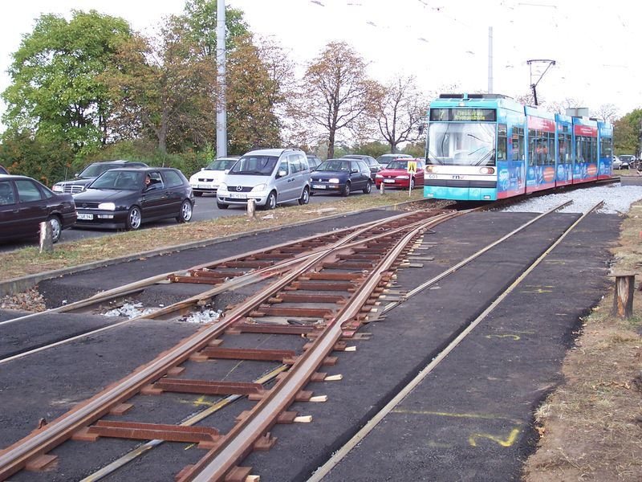  Kletterweichen on section of segregated LRT route in Mannheim note temporary tarmac infill up to rail head to support temporary track and wooden wedges to achieve track alignment | 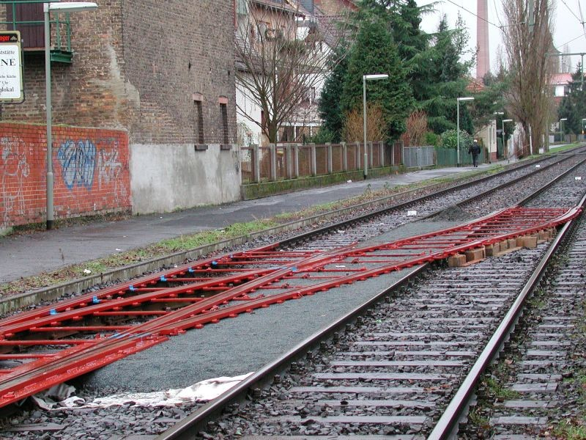  Another view of a temporary crossover on open ballasted track, showing infill in the ‘6ft way’ between tracks and temporary packing between the running rails
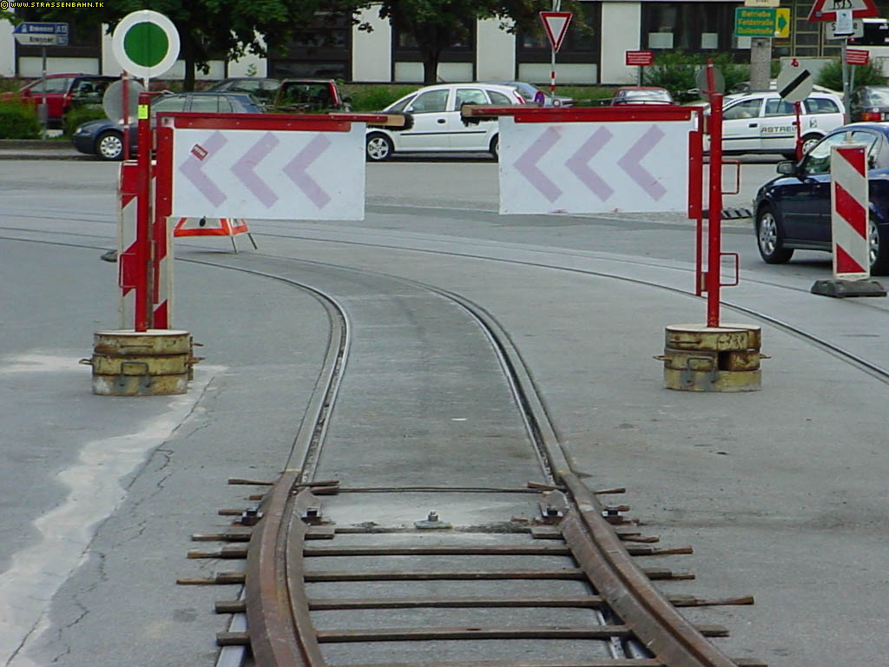 | 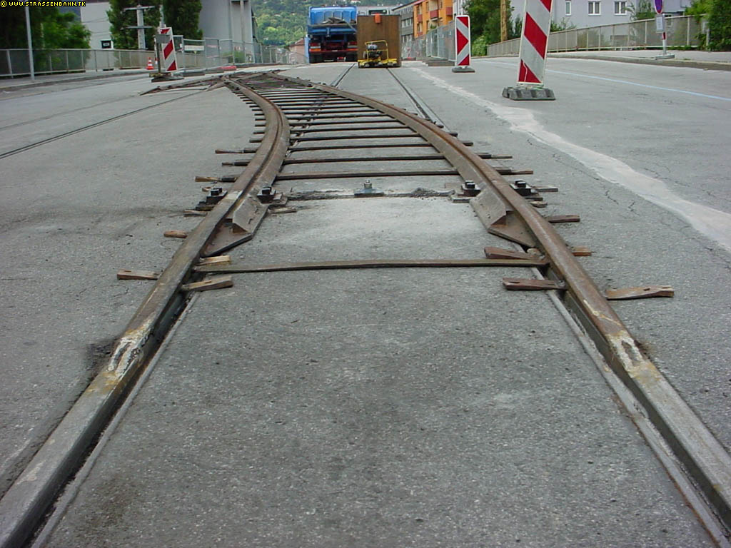

Two low-angle views of temporary track in place,
showing the low height and the relatively gentle vertical curves into and out of the temporary track.
This sort of track can be negotiated by most types of modern low floor trams without problems.

Toronto

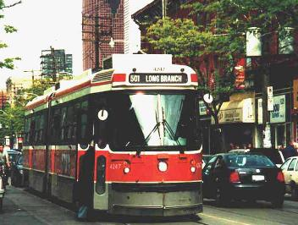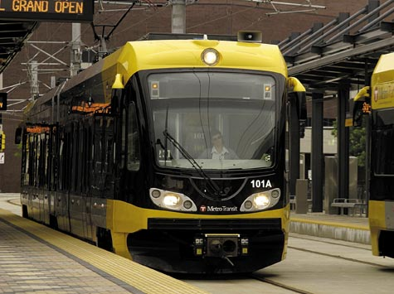

Current 2010 Proposed 2013

Toronto had used temporary track up to the late 1920s, but later adopted a policy of using buses to cover for track disruption. However, they invested in a new pair of kletterweichen in 1998 and have used them on major track repairs ever since. TTC has been amassing data to see whether the operating cost savings and marketing value from not replacing streetcars with buses will outweigh the increased construction cost of rebuilding only one track at a time and leaving the utilities in situ.

Source :SMcI Jan 09

